

*Operating Lease Support System Phase-2 Project*

*for*



***Functional Specification FC.AD.2.7***

***Monitor Historical Maintenance of Unit***

Revision 1.0

**PT. Berlian Sistem Informasi**

KTB Annex Bld. 4th Floor, Jl. Jend. A. Yani. Pulomas,

Tel. +62 21 4786 7575 (Hunting) Fax. +62 21 4714964 www.bsi.co.id

Document Control

|  |  |
| --- | --- |
| **Author** | Dimas Oktarianto |
| **File Name** |  |
| **Path** |  |
| **Number of Pages** |  |

Revision History

|  |  |  |  |
| --- | --- | --- | --- |
| **Date** | **Revision** | **Description** | **Author** |
| 23/12/2015 | 0.0 | Initial Creation | Dimas Oktarianto |
| 04/01/2016 | 0.1 | QCO Review :   * Revise Distribution List and Document Approval | Dimas Oktarianto |
| 12/01/2016 | 1.0 | 1st Baseline | Dimas Oktarianto |

Distribution List

|  |  |  |
| --- | --- | --- |
| Name | Organization | Roles |
| Mr. Yutaro Sanada | Dipo Star Finance, PT | DSF Project Director |
| Mr. Shinji Hosokawa | Dipo Star Finance, PT | DSF Project Advisor |
| Mr. Ahmad Fikri | Dipo Star Finance, PT | DSF Project Advisor |
| Mr. Abdul Somad | Dipo Star Finance, PT | DSF Project Manager |
| Mr. Delta Riangga | Dipo Star Finance, PT | DSF Key User |
| Mr. Mochamad Idris | Dipo Star Finance, PT | DSF Key User |
| Mrs. Herni Hembang | Dipo Star Finance, PT | DSF Key User |
| Mr. Junaidi Didy | Dipo Star Finance, PT | DSF Key User |
| Mr. Dedi Supriyadi | Dipo Star Finance,PT | DSF Key User |
| Mrs. Elke Hilviana | Dipo Star Finance,PT | DSF Key User |
| Mr. Mukhlis Ibrahim | Dipo Star Finance, PT | DSF IT Department Representative |
| Mr. Roby Wijaya | Dipo Star Finance, PT | DSF IT Department Representative |
| Mr. Daiki Kamada | Berlian Sistem Informasi, PT | BSI Project Director |
| Mr. Feri Irawan | Berlian Sistem Informasi, PT | BSI Project Advisor |
| Mr. Grand Zah Putra | Berlian Sistem Informasi, PT | BSI Project Manager |
| Mr. Dimas Oktarianto | Berlian Sistem Informasi, PT | BSI Business Analyst |

Document Approval

By signing this document I acknowledge I have read the document and give the Project Management Team approval to proceed.

|  |  |  |  |
| --- | --- | --- | --- |
| Role | Name | Signature | Date |
| DSF Project Director | Mr. Yutaro Sanada |  |  |
| DSF Project Director | Mr. Shinji Hosokawa |  |  |
| DSF IT Advisor | Mr. Shinya Tsukamoto |  |  |
| DSF IT Advisor | Mr. Ahmad Fikri |  |  |
| DSF PMO | Mr. Roby Wijaya |  |  |
| DSF DSF Biz. Operation Leader | Mr. Abdul Somad |  |  |
| DSF IT Operation Leader | Mr. Mukhlis Ibrahim |  |  |
| BSI Project Director | Mr. Daiki Kamada |  |  |
| BSI Project Manager | Mr. Grand Zah Putra |  |  |
| BSI Technical Leader | Mr. Raymond |  |  |
| BSI Business Analyst | Mr. Dimas Oktarianto |  |  |

Table of Contents

Document Control 2

Revision History 2

Distribution List 3

Document Approval 4

1 Introduction 6

1.1 Purpose 6

1.2 Scope 6

1.3 Definitions, Acronyms, and Abbreviations 6

1.4 References 6

2 Configuration 6

3 Process Specification: AD.2.7 Monitor Historical of Unit 7

3.1 Purpose 7

3.2 Screen of Configuration Access 7

3.3 Screen Functionality 7

3.4 Operation Flow 7

3.5 Screen Detail 9

3.6 Screen Functionality 9

3.7 Operation Description 10

3.8 Data Structure 15

3.9 Screen Item List 16

3.10 Entity Relationship Diagram 17

1. Introduction
   1. Purpose

Functional Specification is a document to describe the detail of functions system which includes screen design and logic formula. This document will be used for system development.

* 1. Scope

Functional Specification Document contains screen design, screen functionality, process flow, and data structure of AD.2.7 Monitor Historical of Unit.

Here are the scope for AD.2.7 Monitor Historical of Unit :

1. **AD.2.7.1 View List of Maintenance Agreement**

To view List Maintenance of Unit based on Agreement, Purchase Order, and Unit Management.

1. **AD.2.7.2 Detail History**

To view detail history of unit.

1. **AD.2.7.3 Print**

To Print History of Unit.

Output from this function is :

1. RPT.AD.2.3. Historical Maintenance Unit
   1. Definitions, Acronyms, and Abbreviations

List of definitions that are used in this document :

1. WO = Work Order.
2. MU = Maintenance Unit.
3. OPL = Operating Lease.
4. BAST = Berita Acara Serah Terima / Handover Report.
   1. References

This functional specification document refers to **“To Be Design” BSI Unit/ Vehicle Maintenance Process**, module:

1. AD.2.7 Monitor Historical Maintenance of Unit.
2. Configuration

N/A

1. Process Specification: AD.2.7 Monitor Historical of Unit
   1. Purpose

Screen of Monitor Historical of Unit will be used by PIC Maintenance to view history maintenance of unit. This Screen Function consist of View list of maintenance agreement, Detail History, and print Historical of Unit.

This function covered by **“Monitor Historical Maintenance of Unit”** screen.

* 1. Screen of Configuration Access

Here are the access rights for **“Monitor Historical Maintenance of Unit”** screen users:

|  |  |  |  |  |
| --- | --- | --- | --- | --- |
| ***User*** | ***Create*** | ***Read*** | ***Update*** | **Authorization** |
| PIC Maintenance | - | V | - | V |
| Admin | - | V | - | V |

Note:

1. Create: related to create Historical Maintenance.
2. Read: related to read display list of view list of maintenance agreement.
3. Update: related to update historical maintenanc
4. Authorization: related to access screen.
   1. Screen Functionality
5. View List of Maintenance Agreement.
6. Detail History.
7. Print Historical of Unit.
   1. Operation Flow

Below is operation flow for Monitoring and print List of Maintenance Agreement to **To Be Design Document Unit/ Vehicle Maintenance**, AD.2.7. Monitor Historical Maintenance of Unit:

|  |  |
| --- | --- |
| **PIC PC** | **Process** |
|  | Agreement  (OPL Agreement)  D:\maintenance_agreement\MaintenanceAgreement_List.JPG    Billing Collection  (TB\_Billing)  Unit Management  (TB\_MGT)  Service History Inquire  (OPLServiceHistory)  Note:  Source  Output & Input |

Below is operation flow of ‘Monitor Historical Maintenance of Unit’ which is used to view historical maintenance of unit by PIC Maintenance.

|  |  |
| --- | --- |
| **PIC PC** | **Process** |
|  | D:\maintenance_agreement\DetailHistoryofUnit.JPG  Historical Maintenance  (TB\_MTN\_HistoryMT)  Note:  Source  Output & Input    WO Number  (Tb\_MTN\_WorkOrder)    Service History  (OPLSerivceHistory)  Monitoring Schedule  (Tb\_MTN\_Monschdl) |

* 1. Screen Detail
* Screen design of ‘Historical Maintenance of Unit’, which will be used as an initial screen for view Monitor Historical Maintenance of Unit. This screen will show historical each unit

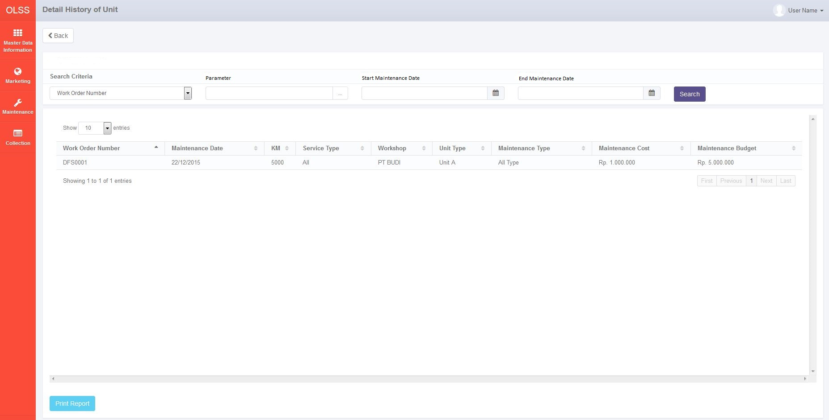

*Screen 1. Detail History of Unit*

* 1. Screen Functionality

Here are the screen functions from each component in Monitor Historical Maintenance of Unit screen:

|  |  |  |  |
| --- | --- | --- | --- |
| ***No*** | ***Component*** | ***Name*** | ***Function*** |
| **Header** | | | |
| 1. | Label | Detail History of Unit | List of History Maintenance of Unit. |
| **Search Criteria** | | | |
| 2. | Drop down box | Search Criteria | To Select Category for searching maintenance data |
| 3. | Text Field | Parameter | To input parameter for searching maintenance data |
| 4. | Date Picker | Start Maintenance Date | To input start maintenance date based on update date when submit maintenance data |
| 5. | Date Picker | End Maintenance Date | To input end maintenance date based on update date when submit maintenance Data |
| 6. | Button | Search | To search maintenance data based on selected criteria |
| **Monitor Historical Maintenance of Unit** | | | |
| 7. | Drop down box | Show Entry | To select number of row data that will be displayed in one screen (paging) |
| 8. | Button | Sort | To sort data on table list of Maintenance, ascending and descending |
| 9. | Label | Work Order Number | To display Work Order Number |
| 10. | Label | Maintenance Date | To display Maintenance Date. |
| 11. | Label | KM | To display KM of Unit |
| 12. | Label | Service Type | To display Service type |
| 13. | Label | Workshop | To display Workshop |
| 14. | Label | Unit Brand | To display Unit Brand |
| 15. | Label | Maintenance Type | To display maintenance type |
| 16. | Label | Maintenance Cost | To display maintenance cost |
| 17. | Label | Maintenance Budget | To display maintenance budget |
| 18. | Label | Showing N to M of X entries | Displaying Maintenance data sequence and the total of maintenance data |
| 19. | Link | First Page | To display first entries page of maintenance data |
| 20. | Link | Previous Page | To display the previous entries page of maintenance data |
| 21. | Link | Page Number | Displaying the Page Number of the List |
| 22. | Link | Next Page | To display the next entries page of maintenance data |
| 23. | Link | Last Page | To show the last page entry |
| **Footer** | | | |
| 24. | Button | Print Report | To Print the report from list of maintenance agreement |

* 1. Operation Description

|  |  |  |
| --- | --- | --- |
| **No.** | **Operation Name** | **Description** |
| 1 | Initial view Historical Maintenance of Unit | The screen for List of Maintenance Agreement:   1. Component Status;  |  |  |  |  | | --- | --- | --- | --- | | Component | Name/Caption | Status | Remark | | Label | Detail History of Unit | Not Active |  | | Drop down | Search Criteria | Active |  | | Field Text | Parameter | Active |  | | Date Picker | Start Period | Active |  | | Date Picker | End Period | Active |  | | Button | Search | Active |  | | Drop down box | Show Entries | Active | As initial by default number of show entries list that will be display is 10 | | Button | Sort | Active |  | | Label | Work Order Number | Not Active |  | | Label | Maintenance Date | Not Active |  | | Label | KM | Not Active |  | | Label | Service Type | Not Active |  | | Label | WorkShop | Not Active |  | | Label | Unit Type | Not Active |  | | Label | Maintenance Type | Not Active |  | | Label | Maintenance Cost | Not Active |  | | Label | Maintenance Budget | Not Active |  | | Label | KM | Not Active |  | | Label | Schedule Date | Not Active |  | | Label | Maintenance Budget | Not Active |  | | Label | Showing N to M of X entries | Not Active |  | | Link | First Page | Active | Active depending on the current entry | | Link | Previous Page | Active | Active depending on the current entry | | Link | Page Number | Not Active |  | | Link | Next Page | Active | Active depending on the current entry | | Link | Last Page | Active | Active depending on the current entry | | Button | Print Report | Active |  | |  |  |  |  | |
| 2 | Display List Historical Maintenance of Unit | Input:   1. Access menu OLSS 2. Select menu Maintenance 3. Select sub menu view list of maintenance agreement. 4. Select Field historical to view historical maintenance each unit.      1. Select number of show list entries : 10, 25, 50, and 100     Process:   1. System will displays data on Detail Historical of Unit based on maintenance date of unit in ascending order. 2. Data that will be displayed are Historical Maintenance of Unit with based on the Tb\_MTN\_WorkOrder (WorkOrderNumber), Maintenance (OPLServiceHistory.IsIregular, ServiceDate, MaintenanceBudget, Maintenance Cost), Tb\_MTN\_Monschdl. 3. Based on **Screen 1. Monitor Historical Maintenance of Unit**, informations related to Maintenance Agreement that will be displayed automatically are: 4. Work Order Number 5. Maintenance Date 6. KM 7. Service Type 8. Workshop 9. Unit Type 10. Maintenance Type 11. Maintenance Cost 12. Maintenance Budget 13. System will display data row based on selected show number entries   Output:   1. Display list of all Historical Maintenance Unit based on Maintenance date of unit in ascending order.   Alternative:  N/A |
| 3 | Searching List Historical Maintenance of Unit | Input:   1. Access menu OLSS 2. Select menu Maintenance 3. Select sub menu view list of maintenance agreement 4. Select detail on field historical 5. Select Search Criteria Drop down boxand click among these:  |  |  | | --- | --- | | **Criteria Searching** | **Constraint Input** | | Work Order Number | varchar | | Maintenance Date | Date | | KM | Number | | Service Type | varchar | | Work Shop | varchar | | Unit Type | varchar | | Maintenance Type | Varchar | | Maintenance Cost | Number | | Maintenance Budget | Number |   Constraint :   1. Search criteria are generated from Tb\_OPL\_SearchCriteria mapping 2. Select Start and End date period to filter based on the Maintenance Date.     Constraint :   * 1. End Period can not be less than Start Period (the End Period will be locked for the date before Start Date).   2. Start Period can not be wless than End Period (the Start Period will be locked for the date after End Date)  1. Click Search button 2. Select number of show list entries : 10, 25, 50, and 100     Process:   1. User can only choose one search criteria to be searched 2. When user click search button, system will displays data on List of Maintenance Agreement based on the selected criteria searching. Formula: 3. If user input Criteria Searching, Criteria Searching param, Start Date, and End Date period, system displays data based on selected criteria searching on selected range end contract, Last Service, Schedule Date. 4. If user input both of Criteria Searching, Criteria Searching param and Start Date, system displays data based on selected criteria searching start from selected Schedule Date until the latest Schedule date. 5. If user input both of Criteria Searching, Criteria Searching param and End Date, system displays data based on selected criteria searching start from the oldest Schedule date until selected update date. 6. If user input Criteria Searching and its param only, system displays all of the list of maintenance agreement data based on the criteria searching only. 7. Data that will be displayed are data based on the TB Monitor Historical (TB\_MTN\_HistoryMT) 8. Based on **Screen 1. List Historical Maintenance of Unit**, informations related to Maintenance Agreement that will be displayed automatically are: 9. Work Order Number 10. Maintenance Date 11. KM 12. Service Type 13. Workshop 14. Unit Type 15. Maintenance Type 16. Maintenance Cost 17. Maintenance Budget 18. System will display data row based on selected show number entries   Output:   1. Display list of all Maintenance Agreement data based on the search result   Alternative:  N/A |
| 4 | Print Report | Input:   1. Access menu OLSS 2. Select menu Maintenance 3. Select sub menu view list of maintenance agreement 4. Select Field History and click Detail button 5. Select Search Criteria Drop down box and click among these:  |  |  | | --- | --- | | **Criteria Searching** | **Constraint Input** | | Work Order Number | varchar | | Maintenance Date | Date | | KM | Number | | Service Type | Varchar | | Work Shop | Varchar | | Unit Type | Varchar | | Maintenance Type | Varchar | | Maintenance Cost | Number | | Maintenance Budget | Number |   constraint :   1. Search criteria are generated from Tb\_OPL\_SearchCriteria mapping. 2. Select Start and End date period to filter based on the Schedule Date.     Constraint:   * 1. End Period can not be less than Start Period (the End Period will be locked for the date before Start Date)   2. Start Period can not be less than End Period (the Start Period will be locked for the date after End Date)  1. Click Search button . 2. Click Print Report button     Process:   1. User can view list of Historical Maintenance data which will be printed, in list of historical maintenance search result list. 2. System will display list Historical Maintenance of Unit in Ms.Excel with file name as below format:   List of Maintenance Agreement Report\_mmddyyyy\_hhmm  Then User can convert that file into PDF format and save file into selected path  Note :  mmddyyyy → month,day,year when report printed  hhmm → hours, minute when report printed   1. Informations related to Historical Maintenance that will be printed are: 2. Work Order Number 3. Maintenance Date 4. KM 5. Service Type 6. Workshop 7. Unit Type 8. Maintenance Type 9. Maintenance Cost 10. Maintenance Budget 11. Historical Maintenance data will be sorted based on Maintenance date service at Historical Maintenance Report   Output:   1. Printed list of all Historical Maintenance data based on the Historical Maintenance search result   Alternative:  N/A |

* 1. Data Structure

**TB\_MTN\_HistoryMT**

|  |  |  |  |  |  |  |
| --- | --- | --- | --- | --- | --- | --- |
| *Field Name* | *Data Type* | *Length* | *Source* | *Remarks* | *Nullable* | *Mandatory* |
| IdHistoryMT | *integer* | *n/a* | Tb\_ MTN\_HistoryMT.IdHistoryMT | ***Primary key*** | No | No |
| WONum | *Varchar* | *50* | Tb\_MTN\_WorkOrder.WorkOrderNum | ***Foreign key***  *Where*  *Tb\_MTN\_HistoryMT.IdWONum = Tb\_MTN\_WorkOrder.WorkNumber* | No | Yes |
| MTDate | *Datetime* | *n/a* | Tb\_MTN\_Monschdl.Schedule | ***Foreign key***  *Where*  *Tb\_MTN\_HistoryMT.MTDate = Tb\_MTN\_Monschdl.Schedule* | No | Yes |
| KM | *Decimal* | *5.0* | *Tb\_MTN\_Monschdl.KM* | ***Foreign key***  *Where*  *Tb\_MTN\_HistoryMT.KM = Tb\_MTN\_Monschdl.KM* | No | Yes |
| ServiceType | *Varchar* | *50* | OPLServiceHistory\_History\_Dtl.MaintenanceItem | ***Foreign key***  *Where*  *Tb\_MTN\_HistoryMT.ServiceType =* OPLServiceHistory\_History\_Dtl.MaintenanceItem | No | Yes |
| Workshop | *Varchar* | *30* | Tb\_MTN\_Monschdl.Workshop | ***Foreign key***  *Where*  *Tb\_MTN\_HistoryMT.Workshop = Tb\_MTN\_Monschdl.Workshop* | No | Yes |
| UnitType | *Varchar* | *50* | *Tb\_MTN\_Monschdl.UnitType* | ***Foreign key***  *Where Tb\_MTNHistoryMT.UnitType = Tb\_MTN\_MonschdlUnitType* | No | No |
| MTType | *Varchar* | *30* | *Tb\_MTN\_Monschdl.MaintenanceType* | ***Foreign key***  *Where*  *Tb\_MTN\_HistoryMT.MTType = Tb\_MTN\_Monschdl.MaintenanceType* | No | Yes |
| MTCost | *Decimal* | *18.3* | OPLServiceHistory\_History\_Dtl.PaymentExpense | ***Foreign key***  *Where*  *Tb\_MTN\_HistoryMT.MTCost =* OPLServiceHistory\_History\_Dtl.PaymentExpense | No | Yes |
| MTBudget | *Decimal* | *18.3* | *Tb\_MTN\_Monschdl.MaintenanceBudget* | ***Foreign key***  *Where Tb\_MTN\_HistoryMT.MTBudget = Tb\_MTN\_Monschdl.MaintenanceBudget* | No | Yes |

* 1. Screen Item List

**RPT.AD.2.3 Report Historical Maintenance Unit**.

|  |  |  |  |  |
| --- | --- | --- | --- | --- |
| *No.* | *Content* | *Description* | *Source* | *Remarks* |
| 1 | Historical Maintenance of Unit | Default Label | Static |  |
| 2. | Period | Period Monthly Report | Based on selected Start Date and End Date that already select by user when print report | *Format display on report:*  *MM/dd/YYYY* |
| 3. | Page | Number of Report Page | Automatically count by number of page | *&[page] of &[total page]* |
| 4. | Printed By | Printed by | Sys.Username | *User Name is the one who login to system* |
|  | Printed Date | Printed Date | Use date at server when button print Report is clicked | *Format display on report:*  *MM/dd/YYYY* |
| 6. | Work Order Number | Work Order Number | TB\_MTN\_HistoryMT.WONum |  |
| 7. | Maintenance Date | Maintenance Date | TB\_MTN\_HistoryMT.MTDate |  |
| 8. | KM | KM | TB\_MTN\_HistoryMT.KM |  |
| 9. | Service Type | Service Type | TB\_MTN\_HistoryMT.ServiceType |  |
| 10. | WorkShop | Work Shop | TB\_MTN\_HistoryMT.WorkShop |  |
| 11. | Unit Type | Unit Type | TB\_MTN\_HistoryMT.UnitType |  |
| 12. | Maintenance Type | Maintenance Type | TB\_MTN\_HistoryMT.MTType |  |
| 13. | Maintenance Cost | Maintenance Cost | TB\_MTN\_HistoryMT.MTCost |  |
| 14. | Maintenance Budget | *Maintenance Budget* | TB\_MTN\_HistoryMT.MTBudget |  |

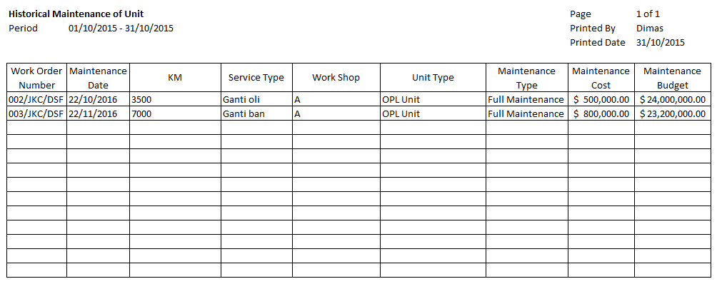

5

4

3

2

1

14

13

12

11

10

9

8

7

6

* 1. Entity Relationship Diagram

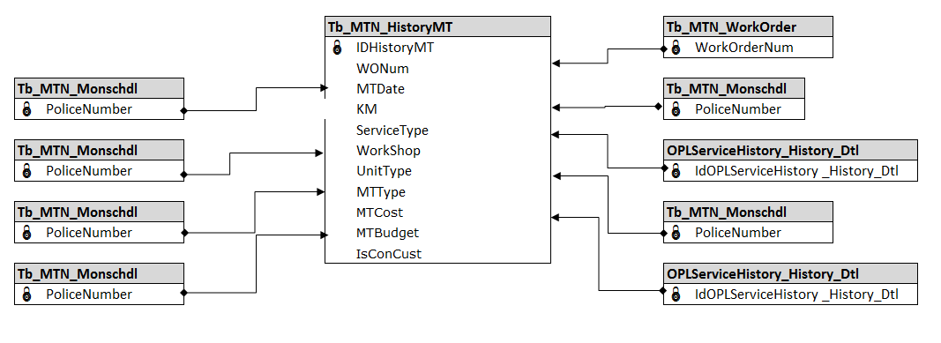

**APPENDIX**

Configuration Access for Maintenance Schedule Creation:

|  |  |  |  |  |  |  |  |
| --- | --- | --- | --- | --- | --- | --- | --- |
| **User** | **Branch** | **Functions** | | | | | |
| **Display List** | **Create** | **Edit** | **View** | **Print Form** | **Print Report** |
| PIC Maintenance HO/Branch | One | V | V | V | V | V | V |
| Area |  |  |  |  |  |  |
| All |  |  |  |  |  |  |
| Marketing Officer | One | V |  |  | V | V | V |
| Area |  |  |  |  |  |  |
| All |  |  |  |  |  |  |
| Head of Branch | One | V |  |  | V | V | V |
| Area |  |  |  |  |  |  |
| All |  |  |  |  |  |  |
| Head of Department | One |  |  |  |  |  |  |
| Area |  |  |  |  |  |  |
| All | V |  |  | V | V | V |
| Regional Manager | One |  |  |  |  |  |  |
| Area | V |  |  | V | V | V |
| All |  |  |  |  |  |  |
| Advisor | One |  |  |  |  |  |  |
| Area |  |  |  |  |  |  |
| All | V |  |  | V | V | V |
| Director | One |  |  |  |  |  |  |
| Area |  |  |  |  |  |  |
| All | V |  |  | V | V | V |
| President Director | One |  |  |  |  |  |  |
| Area |  |  |  |  |  |  |
| All | V |  |  | V | V | V |
| Shareholder's Meeting | One |  |  |  |  |  |  |
| Area |  |  |  |  |  |  |
| All | V |  |  | V | V | V |
|  |  |  |  |  |  |  |  |
| **Legend:** |  |  |  |  |  |  |  |
| V = Have the access |  |  |  |  |  |  |  |